**Sprint 1 Plan**

**Meme Feed**

**Meme Teme**

**1/15/19**

**Revision 0**

**Goal:**

For this sprint, our goal is to create a framework for our application. We want to implement that application basics such as setting up a login page and general feed page

**Task Listing:**

(1) As developers, we want to have a firebase storage system to store information of user accounts and memes. **(1)**

* Set up firebase folders ones for users and ones for memes. **(1)** *(Mia)*

(2) As a User, I want to be able to create and log into an account with my information **(21)**

* Have an Account Login Page to re login or sign up **(1)** *(Emma)*
* Routing from account page to rest of app. **(2)** *(Emma)*
* Allow the user to only have to sign in one time **(3)** *(Siddhi)*
* Ability to log out. **(2)** *(Siddhi)*
* Create an account utilizing, require user to enter (email, full name, user name, passwords) **(9)** *(Jon)*
* Allow the user to have email verification, to secure user profiles. **(5)** *(Jon)*

(3) As a developer, I want to be able to scrape the web to find memes. **(15)**

* Set up folder in firebase for each meme categories (cats, dogs, programming memes), note each meme has the field: Time, Source, Upvote count at time pulled, user who posted **(1)** *(Zac)*
* Change web scraper to pull memes every 12 hours and grab from different reddit threads **(7)** (*Zac*)
* Put web scraper memes into firebase & include time, category, source, upvote count at time pulled, user who posted **(7)** *(Zac)*

(4) As a user, I want a General Feed page to see all of the memes in chronological order. **(8)**

* Create a blank screen as the general feed page **(1)** *(Siddhi)*
  + Pull memes from firebase every 12 hours and put them onto the general feed tab **(5) *(****Mia)*
* Sort memes in the order that they were posted. **(2)** *(Siddhi)*

(5) As a user, I want the General Feed page to have two different views so that I can view at a different pace **(18)**

* Buttons for full feed & scroll which change the view **(3)** *(Siddhi)*
  + Full view for feed with ability to scroll displaying each meme as a square **(7)** *(Mia)*
* Ability to tap on a meme in full feed and have it go to a different page **(3)** *(Emma)*
* Have the ability to scroll through a single feed to see more memes **(5)** *(Emma)*

**Team Roles:**

**Mia:** Product Owner, Scrum Master, Developer

**Emma:**  Developer

**Siddhi:**  Developer

**Jon:** Developer

**Zach:**  Developer

**Initial Task Assignment:**

**Mia:**

(1) As developers, we want to have a firebase storage system to store information of user accounts and memes. **(1)**

* Set up firebase folders ones for users and ones for memes. **(1)** *(Mia)*

(4) As a user, I want a General Feed page to see all of the memes in chronological order. **(8)**

* Pull memes from firebase every 12 hours and put them onto the general feed tab **(5) *(****Mia)*

(5) As a user, I want the General Feed page to have two different views so that I can view at a different pace **(18)**

* + Full view for feed with ability to scroll displaying each meme as a square **(7)** *(Mia)*

**Emma:**

(2) As a User, I want to be able to create and log into an account with my i information **(21)**

* 1 Have an Account Login Page to re login or sign up **(1)**
* 2 Routing from account page to rest of app. **(2)** *(Emma)*

(5) As a user, I want the General Feed page to have two different views so that I can view at a different pace **(18)**

* + 3 Ability to tap on a meme in full feed and have it go to a different page **(3)** *(Emma)*
* 4 Have the ability to scroll through a single feed to see more memes **(5)** *(Emma)*

**Siddhi:**

(2) As a User, I want to be able to create and log into an account with my information **(21)**

* Allow the user to only have to sign in one time **(3)** *(Siddhi)*
* Ability to log out. **(2)** *(Siddhi)*

(4) As a user, I want a General Feed page to see all of the memes in chronological order. **(8)**

* Create a blank screen as the general feed page **(1)** *(Siddhi)*
* Sort memes in the order that they were posted. **(2)** *(Siddhi)*

(5) As a user, I want the General Feed page to have two different views so that I can view at a different pace **(18)**

* Buttons for full feed & scroll which change the view **(3)** *(Siddhi)*

**Zac:**

(3) As a developer, I want to be able to scrape the web to find memes. **(15)**

* Set up folder in firebase for each meme categories (cats, dogs, programming memes), note each meme has the field: Time, Source, Upvote count at time pulled, user who posted **(1)** *(Zac)*
* Change web scraper to pull memes every 12 hours and grab from different reddit threads **(7)** (*Zac*)
* Put web scraper memes into firebase & include time, category, source, upvote count at time pulled, user who posted **(7)** *(Zac)*

**Jon:**

(2) As a User, I want to be able to create and log into an account with my information **(21)**

* Create an account utilizing, require user to enter (email, full name, user name, passwords) **(9)** *(Jon)*
* Allow the user to have email verification, to secure user profiles. **(5)** *(Jon)*

**Initial Burn Up Chart:**

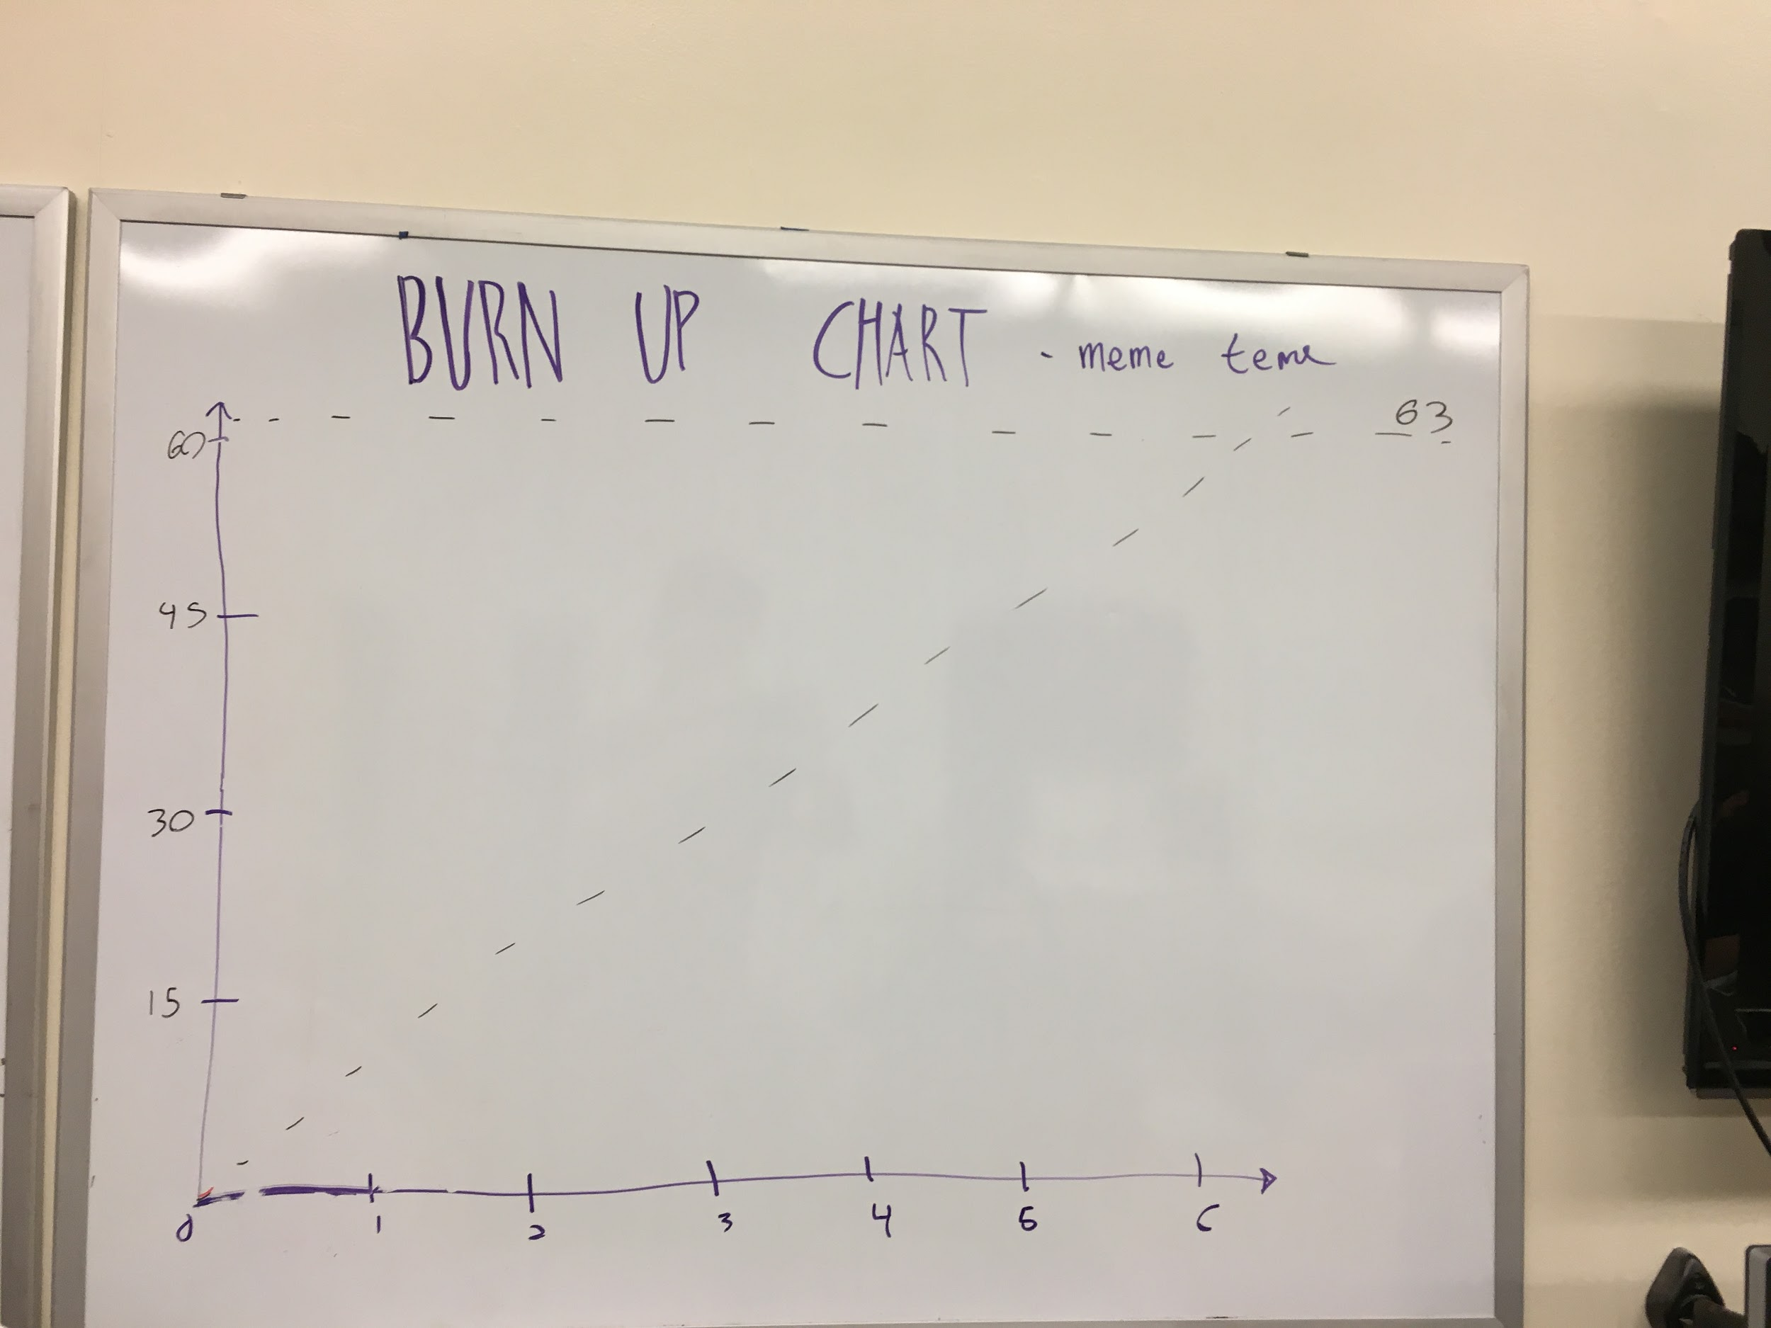

**Initial Scrum Board:**

